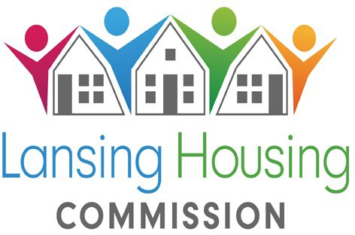
419 Cherry St., Lansing, MI 48933 Telephone: (517) 487-6550 Fax: (517) 487-6977

The Lansing Housing Commission (LHC) will open its:
PROJECT BASED VOUCHER PROGRAM 2 bedroom
Over 55 WAIT LIST
September 4, 2024 at 12:01AM it will remain open until all units are filled
There must be at least 2 Occupants and one must be over 55 or the application will not be approved

The Project Based Voucher Program (PBV Program) is designed to provide low and moderate- income individuals and families with housing assistance in specific units contracted with
LHC. The housing assistance is tied to the unit and cannot be moved.

LHC will accept preliminary online applications for the following Project Based Voucher sites, beginning on:

September 4, 2024 @ 12:01AM

- Stadium Senior: Location: Lansing Michigan 55 and older 2 BEDROOMS ONLY
- At least 2 occupants Required
Applications will be available online only at https://waitlistcheck.com/MI746-4455
The link to apply can also be found on our website at www.lanshc.org
During this period, applications may be submitted anytime, day or night, from a private computer or device with Internet access.

- Applicants need to have an email address, along with the name, date of birth, social security number, income, and asset information of all household members. When the application is complete, applicants should print or save the confirmation page as a receipt for their records.
- Do Not submit more than one application for any member of your household. Duplicate applications will disqualify your household.
- Applications with not enough or too many household members will be placed inactive.
You can check your status to see if you were randomly selected for the waiting list at www.waitlistcheck.com (using the email address and password you created)
No phone calls will be accepted regarding the waiting list selection.
LHC is a federally funded Public Housing Agency which provides housing opportunities for low-income families. Prior to admission, LHC verifies household income, family composition and other circumstances, including criminal history, for all adults in the household.

NONDISCRIMINATION
LHC prohibits discrimination in employment, services, and activities on the basis of race, color, creed, religion, sex, ancestry, familial status, marital status, national origin, sexual orientation, age, disability, source of income or other legally protected status. LHC affirms its commitment to equal opportunity and equal access to services.


TDD/TTY #: 1-800-545-1833 Ext. 919 ”Equal Housing Opportunity” 
Lansing Housing Commission Page 1 of 1

