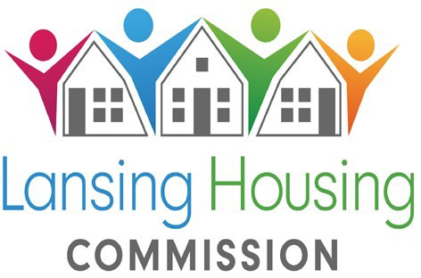
419 Cherry St., Lansing, MI 48933 Telephone: (517) 487-6550 Fax: (517) 487-6977

The Lansing Housing Commission (LHC) will open its:
PROJECT BASED VOUCHER PROGRAM WAIT LIST ON November 27, 2024 at 12:01AM- December 11, 2024 @11:59PM

The Project Based Voucher Program (PBV Program) is designed to provide low and moderate- income individuals and families with housing assistance in specific units contracted with
LHC. The housing assistance is tied to the unit and cannot be moved.

LHC will accept preliminary online applications for the following Project Based Voucher sites, beginning on:

November 27, 2024 @ 12:01AM- December 11, 2024 @ 11:59PM

For applicants with 2 to 6 persons only. Any other applications will be placed inactive.
- Stadium Senior: Location: Lansing Michigan 55 and older (2 Bedrooms, 2 person minimum)
- Walter French 2 & 3 Bedrooms
- Oliver Gardens 2 Bedrooms 55 and Older
- 2 & 3 Bedroom Scattered Sites throughout the city
TO APPLY USE THE LINKS BELOW
55 and older at applicants can apply online only @ https://waitlistcheck.com/MI746-4480
2 & 3 Bedroom applicants can apply online only @ https://waitlistcheck.com/MI746-4481
The link to apply can also be found on our website at www.lanshc.org
During this period, applications may be submitted anytime, day or night, from a private computer or device with Internet access.

Persons who do not have Internet access, or need assistance in completing the application may apply at the Lansing Commission Office located at 419 Cherry Lansing, MI 48933 between 9:00AM-11:30AM and 1:30PM-4:30PM on Tuesday December 3, 2024 and again on Tuesday December 11, 2024. Limited time slots will be available.
- Applicants need to have an email address, along with the name, date of birth, social security number, income, and asset information of all household members. When the application is complete, applicants should print or save the confirmation page as a receipt for their records.
- Do Not submit more than one application for any member of your household. Duplicate applications will disqualify your household.
- Anyone who applies AT ANY TIME during the preliminary application period has an equal chance to be randomly selected for the for the 250 waiting list slots.
You can check your status to see if you were randomly selected for the waiting list at www.waitlistcheck.com (using the email address and password you created)
after December 18 , 2024. No phone calls will be accepted regarding the waiting list selection.
LHC is a federally funded Public Housing Agency which provides housing opportunities for low-income families. Prior to admission, LHC verifies household income, family composition and other circumstances, including criminal history, for all adults in the household.

NONDISCRIMINATION
LHC prohibits discrimination in employment, services, and activities on the basis of race, color, creed, religion, sex, ancestry, familial status, marital status, national origin, sexual orientation, age, disability, source of income or other legally protected status. LHC affirms its commitment to equal opportunity and equal access to services.


TDD/TTY #: 1-800-545-1833 Ext. 919 ”Equal Housing Opportunity” Lansing Housing Commission Page 1 of 1

