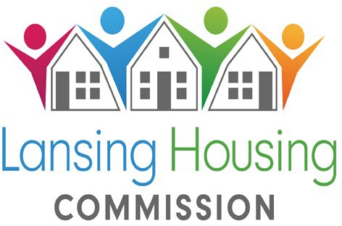
419 Cherry St., Lansing, MI 48933 Telephone: (517) 487-6550 Fax: (517) 487-6977

The Lansing Housing Commission (LHC) will open its:
Elderly Only
2 bedroom Project Based Voucher Waiting List
February 18, 2025 at 12:01AM and will close on February 28 at 11:59 p.m.
There must be at least 2 Occupants and no more than 4 occupants or the application will not be approved

The Project Based Voucher Program (PBV Program) is designed to provide low and moderate- income individuals and families with housing assistance in specific units contracted with
LHC. The housing assistance is tied to the unit and cannot be moved.

LHC will accept preliminary online applications for the following Project Based Voucher sites, beginning on:

February 18, 2025 @ 12:01AM

Stadium Senior 2 bedrooms only
ONE must be over 55 and additional household members must be over 50
At least 2 occupants Required and no more than 4 in the household
Applications will be available online only at https://waitlistcheck.com/MI746-4503
The link to apply can also be found on our website at www.lanshc.org
During this period, applications may be submitted anytime, day or night, from a private computer or device with Internet access.

- Applicants need to have an email address, along with the name, date of birth, social security number, income, and asset information of all household members. When the application is complete, applicants should print or save the confirmation page as a receipt for their records.
- Do Not submit more than one application for any member of your household. Duplicate applications will disqualify your household.
- Applications with not enough or too many household members will be placed inactive.
You can check your status to see if you were randomly selected for the waiting list at www.waitlistcheck.com (using the email address and password you created)
No phone calls will be accepted regarding the waiting list selection.
LHC is a federally funded Public Housing Agency which provides housing opportunities for low-income families. Prior to admission, LHC verifies household income, family composition and other circumstances, including criminal history, for all adults in the household.

NONDISCRIMINATION
LHC prohibits discrimination in employment, services, and activities on the basis of race, color, creed, religion, sex, ancestry, familial status, marital status, national origin, sexual orientation, age, disability, source of income or other legally protected status. LHC affirms its commitment to equal opportunity and equal access to services.


TDD/TTY #: 1-800-545-1833 Ext. 919 ”Equal Housing Opportunity” 
Lansing Housing Commission Page 1 of 2

Project Based Voucher (PBV) Application Process

- When the PBV waiting list opens it will be announced with all agencies as well as on our website at www.lanshc.org

- All applications must be completed online only. We do not accept any applications at any LHC office.

- You may have only ONE application open with the PBV waitlist as well as at each community/development LHC operates.

- Once the list closes we will complete a random lottery drawing. Everyone who applies at any time during the electronic application period has an equal chance to be randomly selected for one of the waiting list slots.

- You can check your application status of any LHC application by going to www.waitlistcheck.com after the date that will be specified with the waiting list opening announcement. Information regarding your status will not be available at any LHC office or via phone. To log in use the Log In I.D. and password you selected when you applied.

- You must keep your address updated in order to be notified when we are ready to process your eligibility paperwork. If your address is not updated we will place you inactive. To update your address go to www.waitlistcheck.com and click on send email next to the list you need to update. You must update each list individually.

- Statuses are as follows: “Inactive Lottery Not Selected” means that you were not one of the random lottery selections and are now inactive and must reapply again when the list reopens. “Active” means that you were selected as a random lottery selection and when we are ready to process your eligibility paperwork we will notify you by mail. Once you have been placed inactive your status will be updated accordingly based on the reason for denial or being placed inactive.

- Once your application has been pulled for processing and all supporting documents have been received by LHC it takes between 4 and 12 weeks to process the paperwork, complete background check and approve or deny the application.

- We do not accept walk in or phone call questions while you are on the waiting list. All questions should be submitted via email only.

